1. What are the benefits of using CSS?

--> By CSS we can style web page.

--> Benefit of CSS is ability to separate content from presentation.

1. What are the disadvantages of CSS?

--> Overusing of CSS can slow down the website’s performance.

-->CSS can not look same in all browser.

1. What is the difference between CSS2 and CSS3?

--> CSS2 can be used for page layout designing.

--> CSS3 that allows you to build a presentation from documents.

1. Name a few CSS style components.

--> height, width, background-color, background-image, font, font-size, etc…

1. What do you understand by CSS opacity?

--> Opacity specifies the clarity of the image.

1. How can the background color of an element be changed?

--> use the CSS background-color property.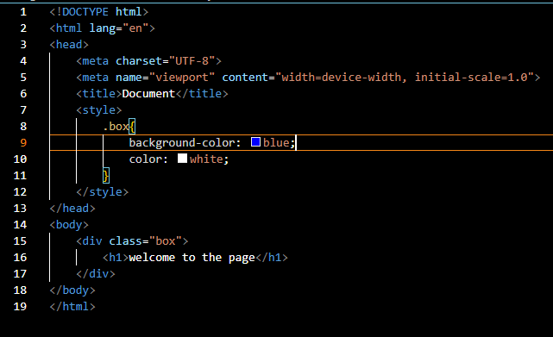

1. How can image repetition of the backup be controlled?

-->  using the background-repeat property that will help to control the repetition of the image.

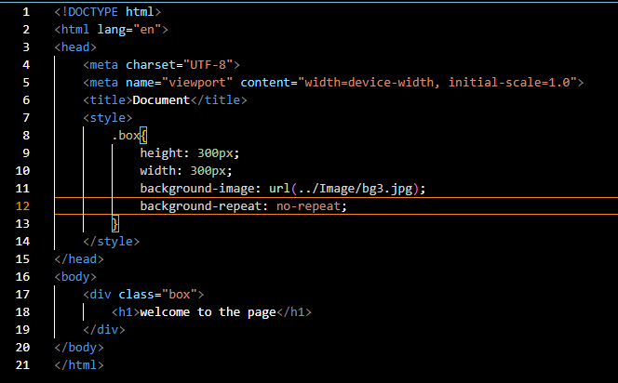

1. What is the use of the background-position property?

-->The background-position CSS property sets the initial position for each background image.

-->The position is relative to the position layer set by background-origin .

1. Which property controls the image scroll in the background?

--> background-attachment property controls the image scroll in the background.

1. Why should background and color be used as separate properties?

--> The background property is a complex property in CSS.

--> if it is combined with color, the complexity will increase.

1. How to center block elements using CSS1?

-->  for centering the element you must set left-margin to auto and right-margin to auto.

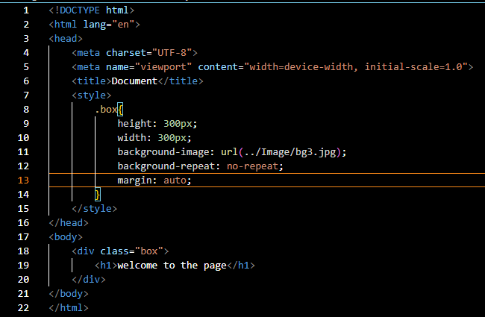

1. How to maintain the CSS specifications?

--> The CSS specifications are maintained by the World Wide Web Consortium .

1. What are the ways to integrate CSS as a web page?

--> Three ways to inyegrate CSS

a. Inline CSS

b. Internal CSS

c. External CSS

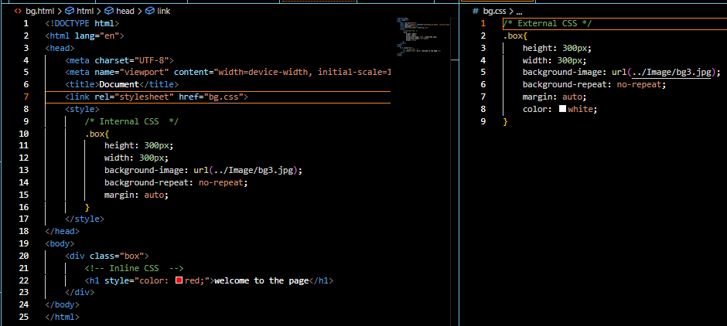

1. What is embedded style sheets?

--> Embedded style sheets allow you to define styles for the whole HTML document in one place.

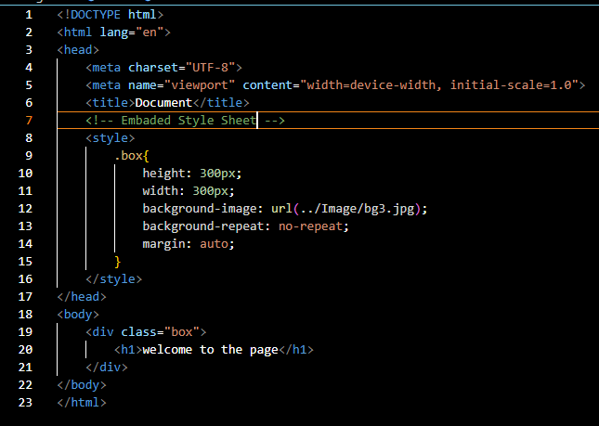

1. What are the external style sheets?

--> An external style sheet is a file with .css extension that contains CSS definitions for a webpage.

1. What are the advantages and disadvantages of using external style sheets?

--> The advantage to using external style sheets is that you can apply styles to multiple web pages.

--> The disadvantage With an external style sheet, you have less control over the specific elements on a page.

1. What is the meaning of the CSS selector?

--> CSS selectors are used to select the HTML elements you want to style.

18.What are the media types allowed by CSS?

CSS supports various media types, which allow you to apply different styles based on the device or medium on which the content is being displayed. Here are the common media types allowed by CSS

all: Applies to all media types.

screen: Applies to screens, such as desktops, laptops, tablets, and smartphones.

print: Applies to printed documents or print preview.

speech: Applies to speech synthesizers or screen readers.

braille: Applies to braille tactile feedback devices.

embossed: Applies to paged braille printers.

handheld: Applies to handheld devices like mobile phones.

projection: Applies to projected presentations, such as slideshows.

tv: Applies to television-type devices.

19.What is the rule set?

In CSS, a rule set consists of two main components: a selector and one or more declarations. Together, they define how a particular HTML element or set of elements should be styled.

Here's the basic structure of a CSS rule set:

Selector: The selector determines which HTML elements the rule set will apply to. Selectors can target elements based on their type (e.g., div, p), class (e.g., .myClass), ID (e.g., #myElement), attributes (e.g., [type="text"]), or their relationship with other elements (e.g., div p for descendant selectors).

Declaration Block: The declaration block is enclosed within curly braces {} and contains one or more property-value pairs. Each property specifies a CSS property (e.g., color, font-size, margin) that you want to style, followed by a colon :, and its corresponding value. Multiple declarations are separated by semicolons ;.